Question 6

Change the native VLAN on a trunk port. Test for VLAN mismatches and troubleshoot.

The cause of changing VLAN

* + The native vlan mismatch may lead to data leakage. Let’s say an untagged vlan arries. The switch 1 will treat it as different vlan and vice versa. This can break vlan isolation
  + If Spanning tree protocol is enabled then it will block the trunk which is inconsistent
  + Some switchs may drop the packet if it found any vlan mismatch
  + Some time you may able to send packet with mismatch lan setting. But it is not reliable. This may occur any issue in future

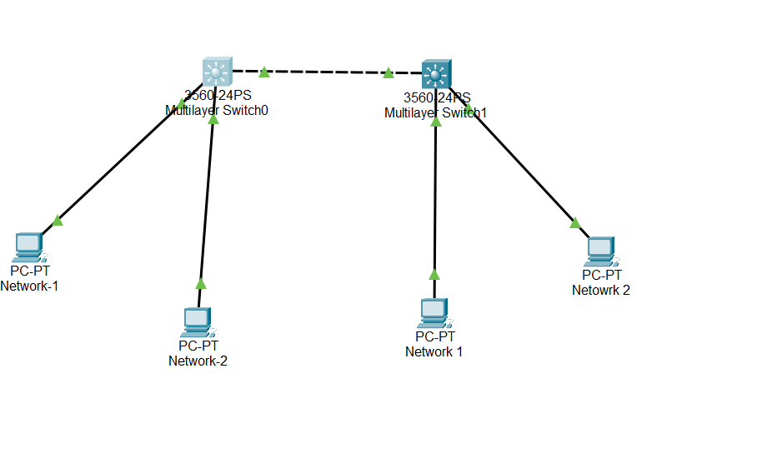

Now we are checking native vlan thourgh show interface trunk command

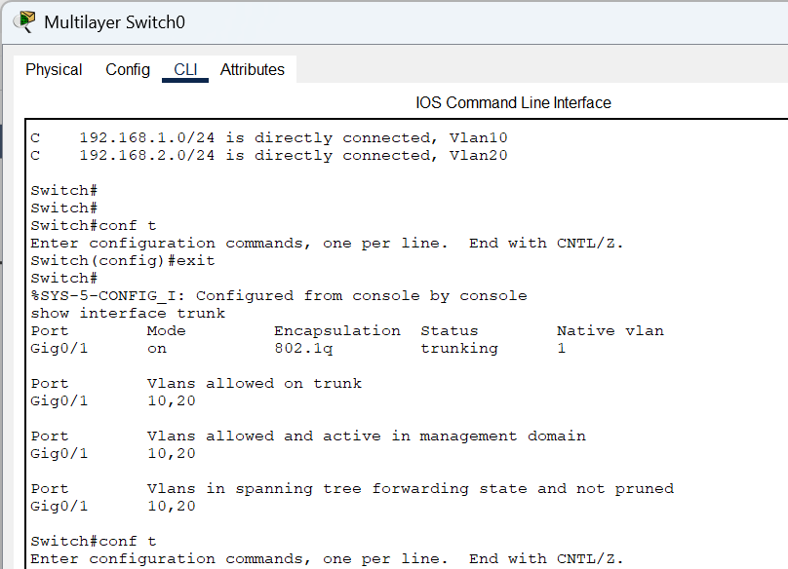

Now setting the native vlan to 100

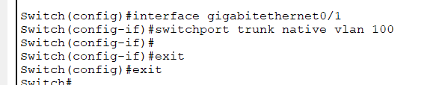

As you see we get cisco discover packet error occurs.



In switch 1 change the native vlan to 100

